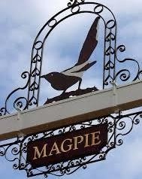
STONHAM PARVA
PARISH COUNCIL
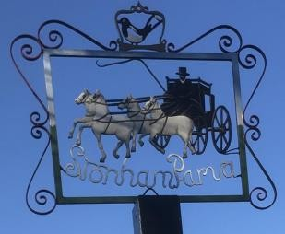
Annual Parish Council meeting to be held in St Mary’s Church, Church Lane at 7.30pm on Monday 20th May 2024 for the purpose of transacting the following business.
Filming, photography, recording or reporting of the meeting is permitted
14th May 2024

PUBLIC PARTICIPATION – Should any Parishioner wish to speak on any item on the agenda, please be available by 7.30pm

A G E N D A
- Welcome
- Apologies
- Approval of Absence
- To receive Councillor’s Declarations of Interest in any item on the agenda
- To receive any dispensations
- To confirm & sign minutes of the Parish Council meeting 15th April 2024
- Reports
  - County Councillor
  - District Councillor
  - Footpaths/Pavements
  - Cemetery/St Mary’s Churchyard
  - Play Area
  - Neighbourhood Watch
  - SALC

- Communication
- Planning Applications
- Roads/Road Safety
- Training/Conferences
- Governance – CIL Return 23/24
- Finance
- Allotments
- Events/Fundraising
- Magpie Sign
- Woodland
- Date of next Meeting – 17th June 2024
- Close of Meeting

