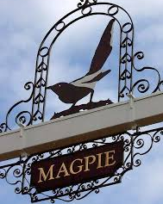
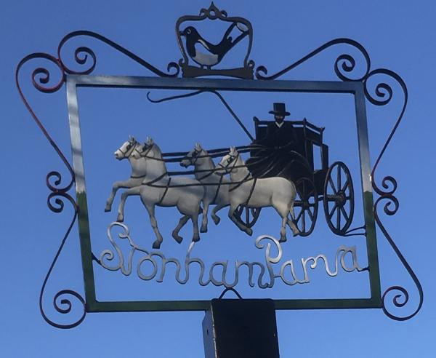
STONHAM PARVA
PARISH COUNCIL

Clerk: Wendy Brame 6 Turnpike,
Tel: 01449 711178 Stonham Parva
Email: clerk@stonhamparvapc.org.uk Stowmarket IP14 5JS

Safeguarding Policy

This policy will enable Stonham Parva Parish Council to demonstrate its commitment to keeping safe both vulnerable adults and children and young people in the community.

Policy Statement
The policy is in place in order for Councillors to work to prevent abuse and know what to do should a concern arise. They will enable Stonham Parva Parish Council to:
Promote good practice and work in a way that can prevent harm and abuse occurring.
Ensure that any allegations of abuse or suspicions are dealt with appropriately and the person experiencing the abuse is supported.

Definitions

Child - “Anyone who has not yet reached their 18th birthday”. Children Act 1989.

Adults at Risk - An individual who “Have needs for care and support, is experiencing, or at risk of those care and support needs is unable to protect themselves from either the risk of or the experience of abuse or neglect”. Care Act 2014.

Responsibilities of the Parish Council
- To accept the moral and legal responsibility to implement procedures, to provide a Duty of Care for children, young people and adults at risk of abuse, safeguard their wellbeing and protect them from abuse.
- To raise awareness of safeguarding to ensure that everyone can play their part in preventing and identifying and responding to abuse and neglect.
- To ensure that all councillors, volunteers and any paid members of staff are familiar with the policy and any associated procedures.
- To work with other agencies within the framework of both the Local Safeguarding Board (LSCB) and the Suffolk Safeguarding Adults Board (SSAB).
- To act within its confidentiality policy and will usually gain permission from adults before sharing information about them with another agency. The safeguarding of a child or an adult who is at risk or if a crime has been committed will override any need for consent.
- To make a safeguarding referral to Customer First1 as appropriate i.e., if there is an immediate danger or the child/adult is at risk of harm.
- To ensure that all new Councillors are provided with a copy of the safeguarding policy.
- To ensure all contractors/partners working directly with the Parish Council meets the safeguarding standards as expected by the Parish Council (A copy of the safeguarding policy must be given to any contractor/partner).
- To require all Councillors/volunteers and anyone paid to adopt and abide by this safeguarding policy and to understand their responsibilities therein.
- To monitor and evaluate the policy annually or in the light of any changes to Government legislation and guidance.
- To ensure there is a designated lead person for safeguarding in the Parish Council.
- To ensure as far as is reasonably practicable that everyone is safe and secure in any facility or environment it provides or facilitates.
- DBS checks will be required if any Councillor, volunteer of paid member of staff is required is required to teach, train, instruct, care for or supervise children.
- To ensure records are kept of any referrals and any notes, records of conversations concerning that referral are kept in the folder and that it is stored in a secure place with limited access to designated people.

Responding to Abuse or an Allegation
- Reassure the person concerned.
- Listen to what they are saying.
- Record what they are saying.
- Record what you have been told/witnessed as soon as possible.
- Remain calm and do not show shock or disbelief.
- Tell them that the information will be treated seriously.
- Ask questions to ensure you gather the full facts but do not start to investigate or ask detailed probing questions.
- Use the vulnerable adult’s/child’s words where possible.
- Don’t promise to keep it a secret.
- Tell the child or vulnerable adult what you are going to do next to get help to keep him/her safe.
- Comply with the Parish Council’s Data Protection Policy.
Types of Abuse
There are four main types of abuse: physical abuse, emotional abuse, sexual abuse and neglect. It is important to note that self-neglect is part of neglect.

Allegations Made Against a Councillor/Volunteer/Paid Member of Staff
This should be reported to the designated safeguarding lead. If appropriate, the designated safeguarding lead will consult with/make a referral to the LADO (Local Authority Designated Officer). The procedures for LADO referrals can be found on the LSCB/SAB websites.
http://www.suffolkscb.orguk/
https://www.suffolkas.org/

Designated Lead
Councillor Kate Dawson
Tholt-y-Will, Church Lane, Stonham Parva, IP14 5JL
Phone: 07825 737792

1 Making a Referral

Please dial 999 if the person is in immediate danger.

For Concerns about a Child
Complete a Multi-Agency Referral Form (MARF) online: http://www.suffolkscb.org.uk/working-with-children/how-to-make-a-referral/ or telephone Customer First on 0808 800 4005.

For Concerns about an Adult
Click on the ‘Make a Referral’ button on the Suffolk Safeguarding Adults Board website https://www.suffolkas.org/ or telephone Customer First on 0808 800 4005.

For advice regarding a referral, professionals can contact the MASH Professional Consultation Line on 0345 606 1499.

