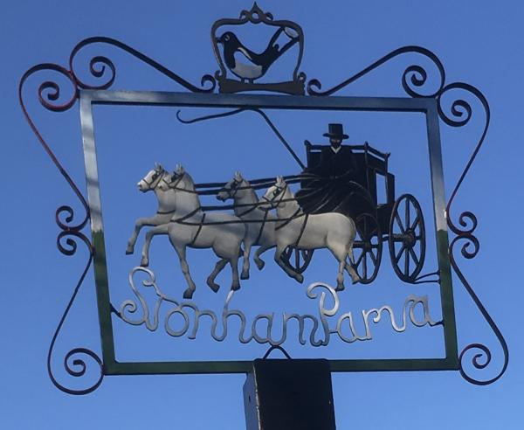
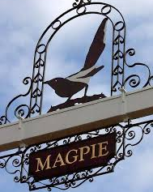
STONHAM PARVA
PARISH COUNCIL

Parish Council meeting to be held in St Mary’s Church, Church Lane at 7.30pm on Monday 17th July 2023 for the purpose of transacting the following business. Filming, photography, recording or reporting of the meeting is permitted 12th July 2023

PUBLIC PARTICIPATION – Should any Parishioner wish to speak on any item on the agenda, please be available by 7.30pm

A G E N D A

- Apologies
- To receive Councillor’s Declarations of Interest in any item on the agenda
- To receive any dispensations
- To confirm & sign minutes of the Parish Council meeting 26th June 2023
- Reports
a) County Councillor
b) District Councillor
c) Footpaths/Pavements
d) Cemetery
e) Playing Field
f) Neighbourhood Watch
g) Tree Warden
h) SALC
- Communication
- Planning Applications
- Roads/Road Safety
- Training/Conferences
- Governance – Internal Audit Action Plan, Asset Register
- Finance – Quarterly Accounts, Internal Control Measure
- Grounds Maintenance Contract
- Allotments
- Events/Fundraising
- Magpie Sign
- St Mary’s Church
- Date of next Meeting – 21st August 2023
- Close of Meeting

