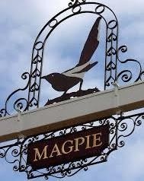
STONHAM PARVA
PARISH COUNCIL
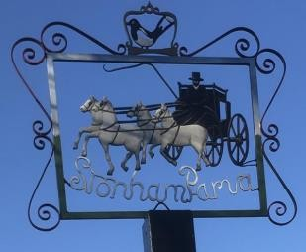
Parish Council meeting to be held in Stonham Baptist Church, Norwich Road at 7.30pm on Monday 15th April 2024 for the purpose of transacting the following business.
Filming, photography, recording or reporting of the meeting is permitted
10th April 2024

PUBLIC PARTICIPATION – Should any Parishioner wish to speak on any item on the agenda, please be available by 7.30pm

A G E N D A
- Welcome
- Apologies
- Approval of Absence
- To receive Councillor’s Declarations of Interest in any item on the agenda
- To receive any dispensations
- To confirm & sign minutes of the Parish Council meeting 18th March 2024
- Reports
  - County Councillor
  - District Councillor
  - Footpaths/Pavements
  - Cemetery/St Mary’s Churchyard
  - Play Area
  - Neighbourhood Watch
  - SALC

- Communication
- Planning Applications – Appeal DC/23/03407
- Roads/Road Safety
- Training/Conferences
- Finance – Accounts 23/24, AGAR Exemption
- Governance – Assets Register
- Allotments
- Events/Fundraising
- Magpie Sign
- Woodland
- Date of next Meeting – 20th May 2024
- Close of Meeting

