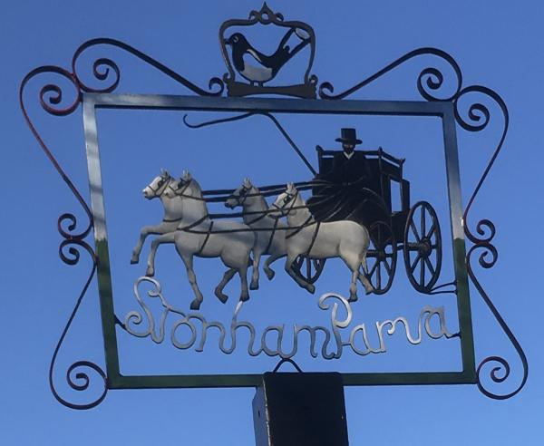
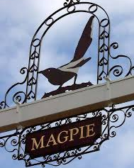
STONHAM PARVA
PARISH COUNCIL

Parish Council meeting to be held in The Baptist Church at 7.30pm on Monday 16th January 2023 for the purpose of transacting the following business. Filming, photography, recording or reporting of the meeting is permitted 10th January 2023

PUBLIC PARTICIPATION – Should any Parishioner wish to speak on any item on the agenda, please be available by 7.30pm

A G E N D A

- Apologies
- To receive Councillor’s Declarations of Interest in any item on the agenda
- To receive any dispensations
- To confirm & sign minutes of the Parish Council meeting 1st December 2022
- Reports
a) County Councillor - Matthew Hicks
b) District Councillor - Mrs Suzie Morley
c) Footpaths/Pavements
d) Cemetery
e) Playing Field
f) Neighbourhood Watch
g) Tree Warden
h) SALC
- Communication
- Planning Applications - DC/22/05467
- Roads/Road Safety
- Training/Conferences
- Governance
- Finance – Budget/Precept
- Allotments
- Fundraising
- Village Sign
- Magpie Sign
- St Mary’s Church
- Community Wood
- Correspondence
- Review of actions not otherwise covered above
- Date of next Meeting – 20th February 2023
- Exclusion of press and public - To agree the exclusion of the press and public in pursuance of Section 1(2) of the Public Bodies (Admission to Meetings) Act 1960 the Press and the Public shall be excluded for the next items of business on the grounds that it is likely to be prejudicial to the public interest by reason of the confidential nature of the business to be transacted.
- CONFIDENTIAL – Clerk’s Salary
- Close of Meeting

