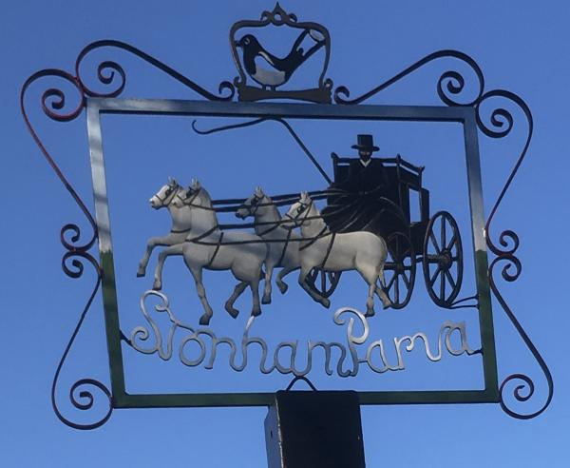
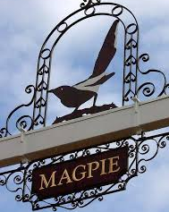
STONHAM PARVA
PARISH COUNCIL

Parish Council meeting to be held in the Baptist Chapel at 7.30pm on Monday 17th January 2022 for the purpose of transacting the following business. Filming, photography, recording or reporting of the meeting is permitted 12th January 2022

PUBLIC PARTICIPATION – Should any Parishioner wish to speak on any item on the agenda, please be available by 7.30pm

A G E N D A

- Apologies
- To receive Councillor’s Declarations of Interest in any item on the agenda
- To receive any dispensations
- To confirm & sign minutes of the Parish Council meeting 20th December 2021
- Covid-19
- Reports
a) County Councillor - Matthew Hicks
b) District Councillor - Mrs Suzie Morley
c) Footpaths
d) Cemetery
e) Play Area – Inspection Report
f) Neighbourhood Watch
g) Tree Warden
h) SALC
- Communication
- Planning Applications
- Roads/Road Safety
- Training/Conferences
- Governance
- Finance – Report for December, Precept
- Fundraising
- Playing Field Purchase
- Correspondence
- Review of actions not otherwise covered above
- Date of next Meeting – 21st February 2022
- Close of Meeting

