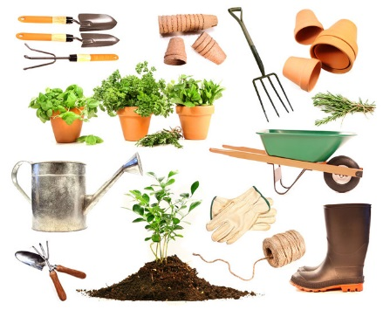
Stonham Parva Allotmenteers

Minutes of Meeting held on Wednesday 27th September @ Magpie Public House, Stonham Parva

Attendees: Wendy Brame; Tim Brame, Mike Gregory; Ivan Richardson, Johanna Richardson, and Sarah Wright

- Welcome
Wendy welcomed everyone to the meeting

- Apologies
Apologies received from Kate Dawson

- Minutes of the last meeting
The minutes from the previous meeting held on Friday 19th May 2017 were agreed.

Water update – The cost of a stand pipe quoted by Anglian Water would be exorbitant so Ivan and Mike are working with the Baptist Church to access their water supply, which is non-metered. Travis Perkins have provided an estimate on materials, not included a ‘mole’, of £280 but would consider a proposal for their community funding scheme. The Parish Council have also indicated they would consider making a contribution.

Manure update – This is still available but it’s a question of time. Everyone offered to help in any way appropriate.

- Chair Report
Wendy confirmed that 18 plots are currently rented. Wendy previously approached other parish councils and they refused to advertise, except Stonham Aspall. Wendy will ask if we can go in their next newsletter as we are already on the website.

- Finance Report
There is £240 in the bank plus £20 to be added.

As we are likely to be around £60 short on rent next year rather than dip into the bank balance it was agreed to increase rents to £22 from April. Depending on the outcome of the water arrangements there may also be a cost contribution to the Baptist Church’s Water Rates that will need to be covered by an additional charge.

- Officers
Sarah took over as replacement Secretary.

- Any other Business

Working Party – Provisional dates agreed Saturday 21st October and Saturday 25th November. Sarah to contact Baptist Church to see if facilities available. Wendy offered hand-reared pulled pork sandwiches.

Christmas Social – An evening in The Magpie – details to be agreed closer to December.

Next committee meeting is Wednesday 7th February 2018

