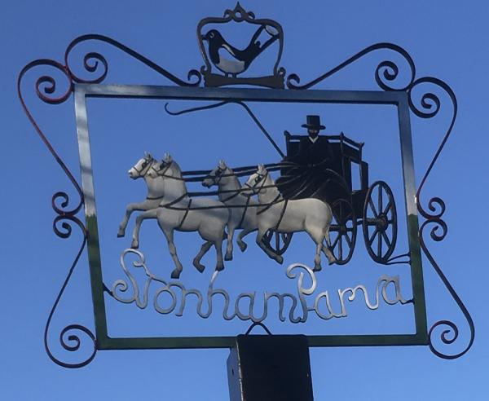
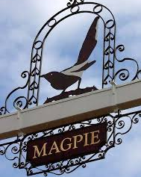
STONHAM PARVA
PARISH COUNCIL

Parish Council meeting to be held in Stonham Baptist Church, Norwich Road at 7.30pm on Monday 19th February 2024 for the purpose of transacting the following business. Filming, photography, recording or reporting of the meeting is permitted
13th February 2024

PUBLIC PARTICIPATION – Should any Parishioner wish to speak on any item on the agenda, please be available by 7.30pm

A G E N D A

- Welcome
- Apologies
- Approval of Absence
- To receive Councillor’s Declarations of Interest in any item on the agenda
- To receive any dispensations
- To confirm & sign minutes of the Parish Council meeting 15th January 2024
- Reports
a) County Councillor
b) District Councillor
c) Footpaths/Pavements
d) Cemetery/St Mary’s Churchyard
e) Play Area
f) Neighbourhood Watch
g) SALC
- Communication
- Planning Applications
- Roads/Road Safety
- Training/Conferences
- Governance – Internal Control Measures, General Reserves Policy
- Finance
- Allotments
- Events/Fundraising
- Magpie Sign
- Woodland
- Date of next Meeting – 18th March 2024
- Close of Meeting

